NHS Lanarkshire

NHS Lanarkshire Psychological Services provide clinical and consultation services to approximately 700,000 people of North and South Lanarkshire. The Service comprises of around 200wte clinical staff from a range of professions. There are Clinical and Counselling Psychologists, Senior Psychological Therapists, Clinical Associate’s in Applied Psychology, Therapeutic Counsellors, and Assistant Psychologists. Together, these clinicians provide a wide range of psychological interventions, across the spectrum of needs, within a variety of community and hospital settings.

NHS Lanarkshire has a mix of urban and rural areas. Service provision is divided into 10 locality areas. There are Psychological Therapies Teams (PTTs) in all 10 localities in addition to many specialist pan-Lanarkshire services. Due to the large geographical area of the board having access to a car during clinical training is easier, however, some trainees have completed training using public transport alone.

PLACEMENTS OFFERED

We are the only health board in Scotland offering placements to trainees on the MSc in Applied Psychology for Children and Young People, the MSc in Psychological Therapies in Primary Care, and both the University of Glasgow and University of Edinburgh Clinical Psychology Doctorate programmes. We also offer placements to Counselling Psychology and Health Psychology trainees.

STRUCTURE OF PSYCHOLOGICAL SERVICES IN LANARKSHIRE

The Director of Psychological Services is Dr Deborah Wilson. We have a CORE management team that oversee the strategic direction of all the psychological services. In addition, there is at least one further consultant in each service responsible for service delivery and operational management.

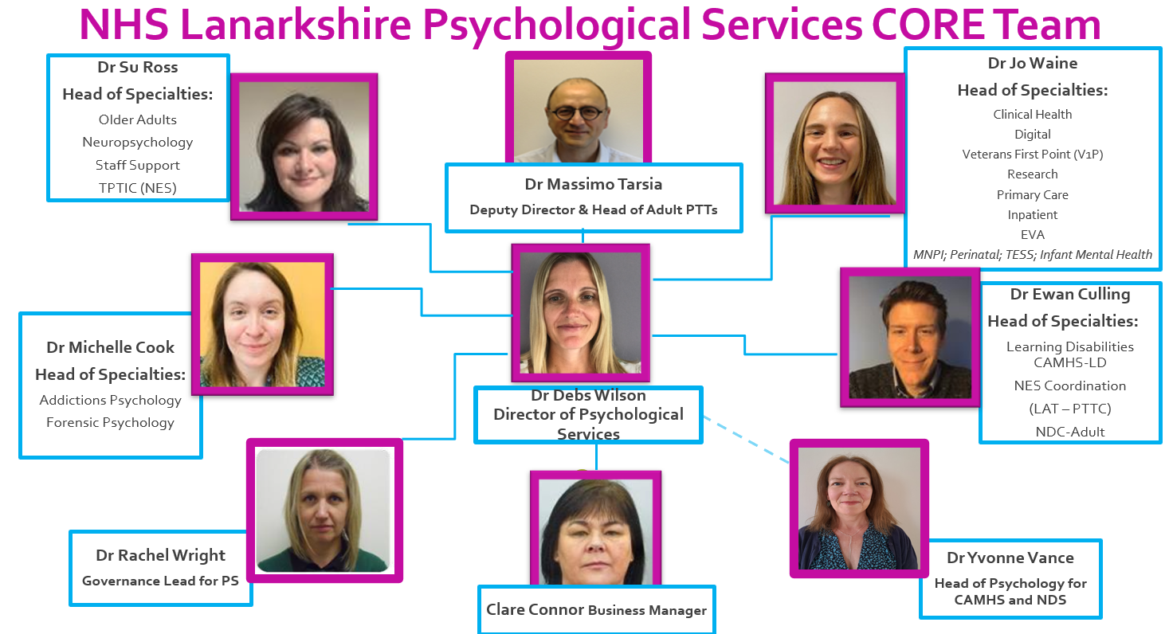

Services are provided in the following areas:

Psychological Therapy Teams (PTTs)

There are Psychological Therapy Teams (PTTs) in each of the 10 localities in Lanarkshire, providing a variety of individual and group therapeutic approaches for adults with mental health difficulties that are having a significant impact on their functioning. Clinicians within the PTTs are highly skilled in a variety of therapeutic models, including CBT, EMDR, CFT, Schema Therapy, and mindfulness. The PTTs work in association with other disciplines within the CMHTs, including psychiatry, nursing, and occupational therapy. A stepped care approach to delivering evidence-based therapies is utilised, enabling individuals to step up or down within the model according to changing need and in response to intervention.

Primary Care Psychology

Established in 2024, Primary Care Psychology is part of NHS Lanarkshire’s evolving Primary Care Mental Health model. With a Pan-Lanarkshire remit, the service provides psychological interventions to individuals aged 16 and above experiencing mild to moderate mental health difficulties. A cornerstone of this work is the large-scale relaunch of Stress Control courses across community sites, delivering low-intensity, evidence-based early interventions close to home. The service is also engaged in an ongoing test of change series, trialling individual interventions such as guided self-help drawing on CBT, ACT, and CFT approaches, and time-limited (up to 15 sessions) high-intensity CBT delivered remotely and following a peripatetic model focussing on areas of greatest demand. In addition to direct clinical work, the team provides supervision, consultation, and training to multidisciplinary colleagues across the Primary Care Mental Health network.

Adult Inpatient Psychology

The service provides psychological input to the four adult psychiatric wards, Intensive Psychiatric Care Unit (IPCU), the specialist psychiatric rehabilitation unit and the community rehab team. The focus of the direct psychological work is assessment and formulation to guide care and discharge planning. The indirect work involves consultation, training and providing a psychological perspective on care to the whole of the MDT.

Psychological Therapies for Older People (PTOP)

The service exists to address the psychological needs of individuals presenting with emotional distress, behavioural disturbance and mental health difficulties predominantly related to issues associated with ageing. This includes complex physical health issues affecting mental health, complex or multiple loss, trauma, role transitions associated with ageing, and cognitive impairment. The service offers neuropsychological assessment to aid diagnosis of organic illness, assessment and intervention of complex distressed behaviours in dementia, and evidence-based psychological therapies (e.g., CBT, IPT, CFT, ACT, and Schema Therapy) delivered on a one-to-one or group basis. It provides input across multiple health and social care settings, including acute and community.

Psychological Services for Adults with Learning Disabilities (PSALD)

PSALD is part of NHSL’s Psychological Services and operates within the Learning Disabilities Service (LDS). It is an area wide service covering all localities in NHS Lanarkshire and is based in Longdales Administration Building on the Kirklands Site. The remit of PSALD is to address the psychological needs of adults with learning disabilities (LD), aged 18 and over, who live in the Lanarkshire Health Board geographical area, and their families, carers and other professionals providing care and support to them. In addition to its delivery of direct clinical services, PSALD has responsibilities for consultation, teaching, research and supervision. The department provides community based clinical input and psychological services to the NHS Lanarkshire multi-disciplinary community learning disability health teams and an inpatient assessment and treatment unit. The department has a major role in providing autistic spectrum disorder services and forensic services to adults with a Learning Disability, in both community and inpatient settings. The Learning Disability Service’s central base houses a variety of specialists including speech and language therapy, psychiatry, physiotherapy and occupational therapy – providing ample opportunity for collaborative working with persons from other disciplines. The department has close links with our counterparts in the CAMHS-LD Service.

Adult Neurodevelopmental Service (ANDS)

The Adult Neurodevelopmental Service (ANDS) is a small, newly formed multi-disciplinary service established in August 2024. The current focus of the service is on autism diagnostic assessment and support.

Tertiary Eating Disorder Specialist Service (TESS)

TESS is a multi-disciplinary team, providing a pan-Lanarkshire service to adults with severe eating disorders resulting in complex needs. There are also adapted referral criteria for young people to minimise the harm that can be caused to their development, to capitalise on better treatment outcomes shown to occur from early intervention, and to offer specific treatments to meet the needs of those in late adolescence. There are opportunities for individual case work, multi-professional working, group interventions, working with carers/families in addition to teaching/training other professionals.

Addiction Psychology Service (APS)

The Addiction Psychology Service (APS) is a Lanarkshire-wide psychological service for individuals with co-existing addiction and mental health problems. Clinicians provide clinical, consultative and training input to all 10 locality-based integrated addiction teams, the community prescribing service, and commissioned third sector addiction services. The service has administrative bases in Coatbridge, Motherwell and Hamilton. APS works to a matched care model of service delivery. Clinicians provide direct psychological assessment and individual and group intervention to those with the most complex mental health and addiction difficulties. Interventions include a phased based approach to trauma recovery which aims to promote psychologically and trauma informed practice across wider addiction services. APS also provide consultation, training and support to assist others to provide lower intensity psychological interventions. Further specialist addiction neuropsychological assessment is also available.

Clinical Health Psychology

The Clinical Health Psychology (CHP) Service is a specialist service for adults who are experiencing severe and complex psychological issues specifically associated with physical health difficulties and/or medical treatment. The service provides a stepped care model of service provision that is designed to increase the efficiency of the service in the context of a limited resource and high demand. CHP provides direct psychological assessment, formulation and intervention for complex cases. In addition, the service provides consultation, training, and supervision to other NHS and non-psychology staff involved in the care of individuals with physical health difficulties who are presenting with psychological difficulties related to their health. We also have specialist services in Pain Management, Blood-Borne Viruses (BBV), and Weight Management, offering assessment and rehabilitation services.

Forensic Clinical Psychology Service

The Forensic Clinical Psychology Team is a pan- Lanarkshire service comprising two teams: The Forensic Mental Health Psychology (FMHS) and Prison Psychology Service (PPS). FMHS Psychology provides input to forensic mental health inpatient services (15 low secure and 12 forensic rehabilitation beds), and the Forensic Community Mental Health Team (FCMHT). The Prison Psychology Service provides input for individuals currently residing within HMP Shotts. The team also offers training, advice and consultation on forensic issues to other services within NHS Lanarkshire, Criminal Justice Social Work, MAPPA etc.

Neuropsychology, including the Stroke Psychology Service and Brain Injury Rehabilitation Service

The Neuropsychology Service is a pan-Lanarkshire service providing assessment, therapy and rehabilitation for patients with organic and functional neurological disorders. The Stroke Psychology Service and Brain Injury Rehabilitation Service provide similar input to their respective clinical populations as part of integrated rehabilitation MDTs. All these services provide training and consultation to acute and mental health services throughout Lanarkshire.

Perinatal Psychology

Perinatal Psychology works with women in the perinatal period who have complex and/or severe mental health difficulties. It is part of the Community Perinatal Mental Health Team (CPMHT) and is based in Coatbridge. This multidisciplinary team covers all of Lanarkshire and includes Psychiatry, Nursing, Social Work, Occupational therapy, Parent-Infant Therapy and Nursery Nursing. Perinatal Psychology provides psychological assessment and intervention, including CBT, CFT, Schema Therapy, EMDR, ACT, and mindfulness. It also provides consultation and training.

Maternity and Neonatal Psychological Interventions (MNPI) Service

This service is based in University Hospital Wishaw and provides a Lanarkshire wide service. It is led by a Consultant Clinical Psychologist, 2 Clinical Psychologists, an Advanced Specialist Midwife in Perinatal Mental Health, and a Therapeutic Counsellor. The main remit is to provide support to parents with complex needs arising from pregnancy or previous pregnancy complications. Psychological interventions, bereavement counselling, specialist midwifery interventions and support are provided for antenatal, neonatal and postnatal parents (up to 1 year post-natal). Common presentations include Antenatal Anxiety and Low Mood in relation to a previous loss or traumatic birth; Antenatal Anxiety and Low Mood in relation to pregnancy or maternity care (e.g. procedural distress, Tokophobia); Acute Stress Response from parents in the Neonatal Unit; Post-natal low mood, anxiety and Post-traumatic stress where there is Birth Trauma (including PTSD), Traumatic Grief.
EVA (End Violence and Abuse against women) Psychology
Based in Coatbridge, but working across Lanarkshire, EVA Psychology is NHS Lanarkshire’s specialist gender-based violence psychology service. EVA Psychology offers psychological assessment and therapeutic interventions on an individual and group basis, for women who have experienced adult interpersonal trauma. The service also provides training to other services and agencies, as well as offering information and advocacy. EVA Psychology provision is informed by gender analyses of violence against women, which includes cultural norms, societal attitudes and gender roles that contribute to the subordination of women and girls; GBV being a function of gender inequality.
Child, Adolescent and Family Services, including the Neurodevelopmental Service (NDS) for Children and Young People

There are four multi-disciplinary locality CAMHS teams and several area wide specialist teams. Multi-disciplinary teams generally consist of Clinical Psychologists, Clinical Associates in Applied Psychology, Child and Adolescent Psychiatrists, Child and Adolescent Mental Health Clinicians and Social Workers, in addition to area wide AHP provision including Speech and Language Therapists, Physiotherapists and Occupational Therapists. CAMHS teams are based across three locations; Airbles Road Clinic in Motherwell, Coathill Hospital in Coatbridge and new facilities in Udston Hospital, Hamilton. The service places strong value on training and CPD, and CAMHS staff deliver a range of therapeutic approaches in line with the evidence base, including CBT, DBT, FBT, IPT, DDP and Family Therapy.

The NDS for Children and Young people is an assessment service for neurodevelopmental conditions including ASD and ADHD. The service is split between Newmains Health Centre, Newmains (for North Lanarkshire) and Udston Hospital, Udston (for South Lanarkshire). The service places value on providing comprehensive neurodevelopmental assessments plus resources for families awaiting assessment and those post-diagnostic to support them with the challenges they face.

Both CAMHS and NDS are multi-disciplinary teams consisting of Clinical Psychologists, Clinical Associates in Applied Psychology, Child and Adolescent Psychiatrists, Child and Adolescent Mental Health Clinicians, Mental Health and Paediatric Nurses, and Social Workers, in addition to area wide AHP provision including Speech and Language Therapists, Physiotherapists and Occupational Therapists.

CAMHS-LD

CAMHS-LD psychology are based in Airbles Road Centre and address the needs of children and young people (aged 5-18) with moderate/severe/profound learning disabilities and tier 3 mental health difficulties. The psychology team are embedded within the multi-disciplinary CAMHS-LD service. Psychology within CAMHS-LD are responsible for oversight of Psychological Therapies within the service and provide supervision and consultation to other members of the service and mainstream CAMHS for children and young people with a Mild Learning Disability.

Digital Psychological Services

Digital Psychological Services is an embedded department working with a wide variety of stakeholders within and out with NHS Lanarkshire Psychological Services. Its aim is to help implement digital and technological developments in order to improve access to high-quality, trustworthy psychological resources for the potential benefit of everyone in Lanarkshire.

Psychological Services Staff Support Team (PSSST)

The Psychological Services Staff Support Team (PSSST) provide expert psychological care for Lanarkshire’s health and social care (H&SC) workforce. PSSST’s One-to-One Service, provides a high intensity clinical service for staff with mental health difficulties and consults with managers and Occupational Health to identify reasonable adaptations to support mental health and wellbeing at work, prevent sickness absence or facilitate early return to work. PSSST’s Consultation and Teams Service works in collaboration with managers, teams, services and other organisational supports to promote workforce wellbeing through bespoke psychologically informed systemic interventions.

TEACHING, TRAINING AND RESEARCH ACTIVITIES

Staff within Psychological Services have close links and develop and deliver a large array of teaching modules, on psychology programmes across Glasgow, Edinburgh, Strathclyde, Caledonian, and Stirling universities. Staff also provide teaching and clinical training to a variety of other professionals and staff, including nurses, health visitors, GPs, trainee psychiatrists, junior medical staff, care provider staff, adoptive and fostering parents, social workers, midwifery staff and allied health professionals.

Dr Andy Siddaway is Psychology Research Lead within Lanarkshire. The service provides encouragement, consultation and support for psychology staff and trainees planning and conducting research and audit/quality improvement projects and are actively involved in developing proposals for trainees.

Training Alignments
For doctorate trainees NHSL offers both national and local aligned placements. The speciality alignments and number of aligned training places vary year to year. If a trainee is offered an alignment in a speciality, that they opted into during recruitment, they will be expected to complete both their research and 3rd year placements within that speciality.

For further information, please contact:
Dr Sally Dewis, Consultant Clinical Psychologist & Local NHS Psychology Tutor
Sally.Dewis@lanarkshire.scot.nhs.uk

